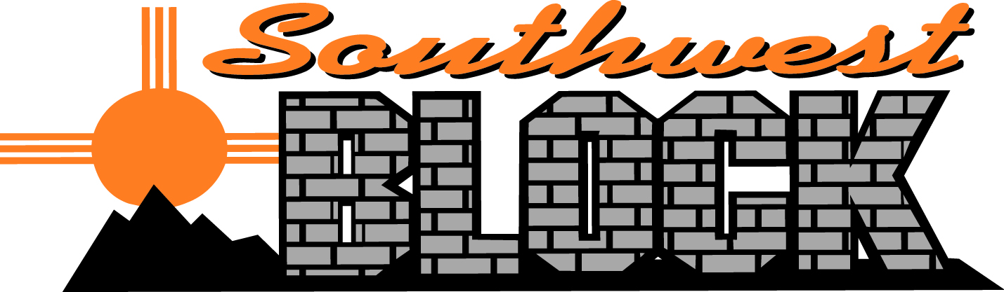

September 28, 2018

Submittal Letter

This letter is to certify that Southwest Block Inc. standard concrete masonry units conform to ASTM designation C-90, for hollow load bearing units as determined by ASTM-140 method of testing.

Southwest Block Medium Weight Concrete Masonry Units are manufactured with volcanic scoria aggregate conforming to ASTM C 331-94 Lightweight Aggregate for Concrete Masonry Units and Siliceous gravel aggregate conforming to ASTM C 33- 97 Standard Specification for concrete aggregate.

Southwest Block Inc. units meet NBS Bulletin 3079 for linear shrinkage requirements maximum .05 of one percent (1%) from saturated to oven dry condition, and the modified British method ASTM C-46,
.065 of one percent (1%), saturated to equilibrium with 17% relative humidity at 122 degrees F.

Sincerely,
JD Carrell

Southwest Block

